SIMATS ENGINEERING ASSESSMENT TOOL 2

COURSE CODE: MLA03
COURSE NAME: Reinforcement learning
NAME: G. Rohit Venkat
REGISTER NUMBER: 192472107

COURSE OUTCOME COVERED

CO4: Evaluate model-based reinforcement learning approaches for prediction, planning, and policy optimisation.( BL3,BL4,BL5)

Assessment Tool Weightage: 40%

Dr G. A. SENTHIL

QUESTIONS: 25 Total Marks: 50

Annexure A

Design and Develop Model

- Model-Based RL Approach –
Draw a flowchart illustrating the complete workflow of a Model-Based Reinforcement Learning agent from environment interaction to policy optimization.
ANS:- Model-Based Reinforcement Learning uses a learned model of the environment to predict future states and rewards. The agent interacts with the environment and collects experience. This experience is used to learn the environment model. The planning module then uses the model to evaluate possible actions and select the best action. The policy is optimized based on these predictions, and the process continues until the policy converges.

Key Components
    - Environment: Provides states and rewards.
    - Model: Predicts future states and rewards.
    - Planning: Evaluates possible actions.
    - Policy: Selects the best action.
    - Reward: Measures the quality of the action.
    - Policy Optimization: Improves the agent's decision-making.

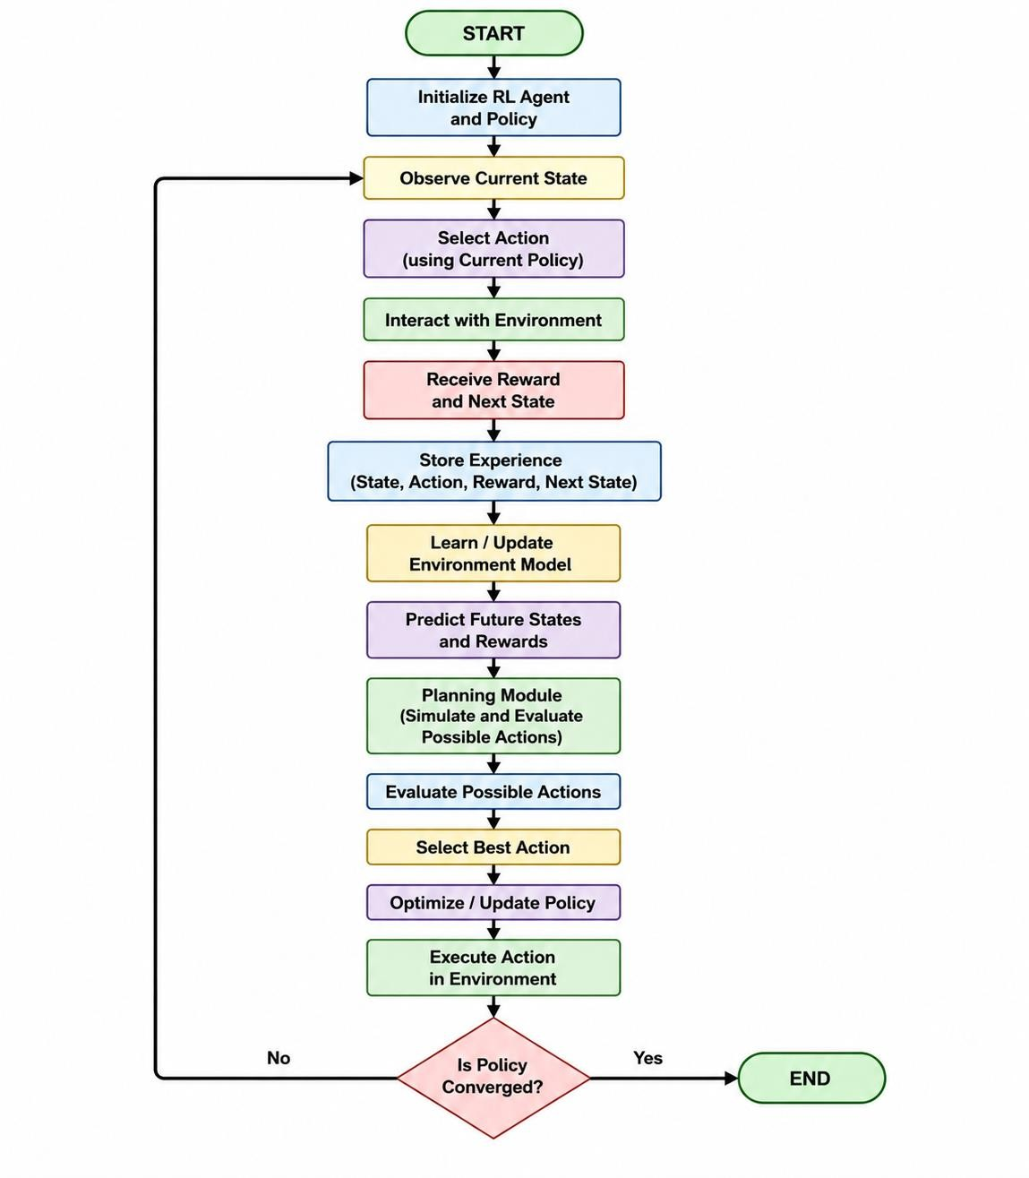

- Analytic Gradient Computation-
Design a concept map showing how gradients are computed and propagated during policy learning.
ANS: - Analytic Gradient Computation is the process of calculating the exact gradient of the policy objective with respect to the policy parameters. The gradient indicates how the policy parameters should be changed to increase the expected cumulative reward.
Key Points • Policy: Determines the action selection using parameters θ.
    - Objective Function: Measures the expected cumulative reward.
    - Gradient Computation: Calculates how the objective changes with respect to policy parameters.
    - Policy Gradient: Gives the direction for improving the policy.
    - Gradient Propagation: Uses the chain rule and backpropagation to propagate gradients through the neural network.
    - Parameter Update: Updates policy parameters using the calculated gradient. • Improved Policy: Produces better actions and higher expected rewards.
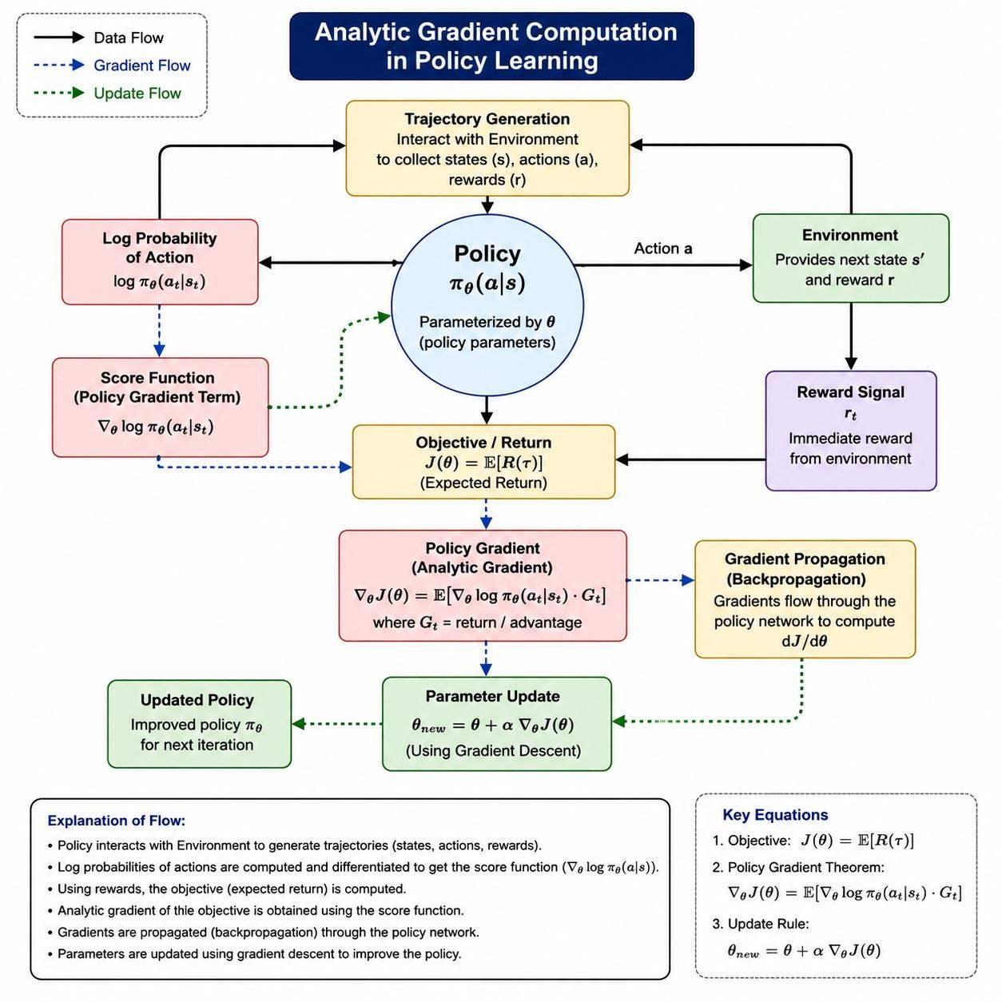

- Sampling-Based Planning-
Draw a flowchart illustrating the sampling-based planning process in ModelBased Reinforcement Learning.
ANS: - Sampling-Based Planning is a Model-Based Reinforcement Learning technique in which the agent samples possible actions or trajectories and uses the learned environment model to predict their future outcomes. The trajectories are evaluated based on their expected rewards, and the action with the best predicted performance is selected.

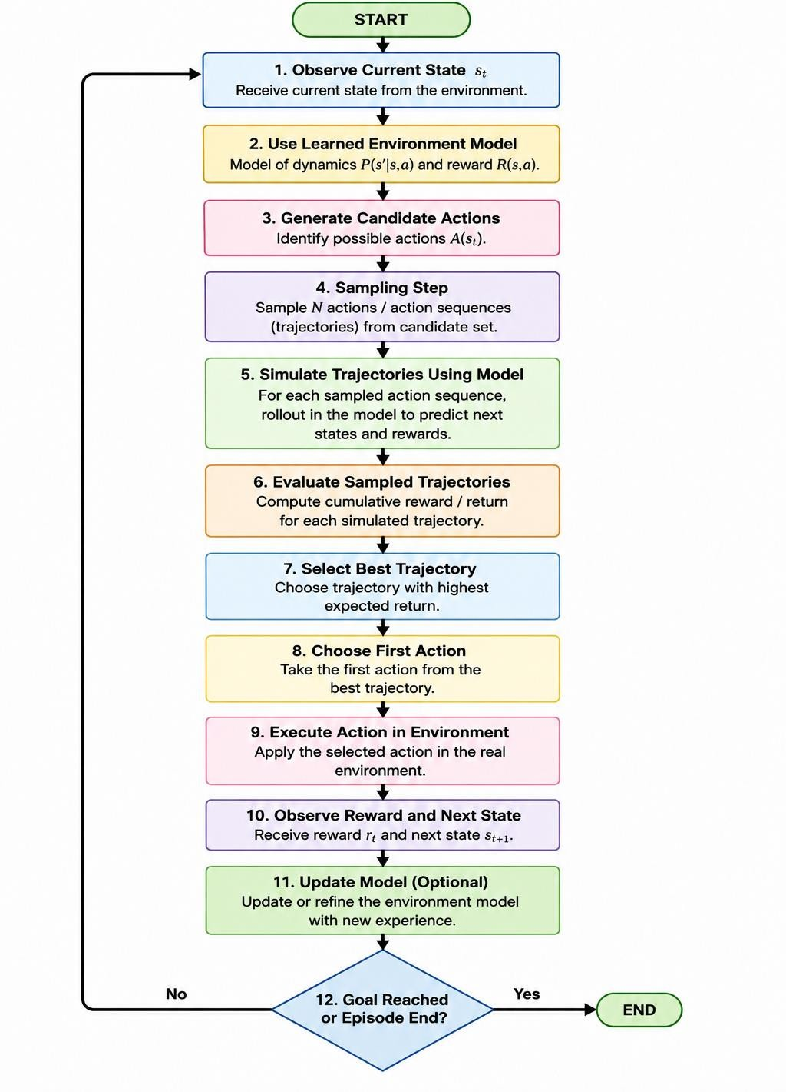
- Model-Based Data Generation-
Draw a flowchart illustrating synthetic data generation using a learned environment model.
ANS: - Model-based data generation uses a learned environment model to create synthetic experiences. The agent first collects real-world experience and trains an environment model. The learned model then predicts future states and rewards to generate additional simulated experiences. These synthetic experiences are stored and combined with real data to train and improve the policy.
Advantages:
  - Improves sample efficiency
  - Reduces real-world interaction
  - Provides additional training data
  - Reduces training cost

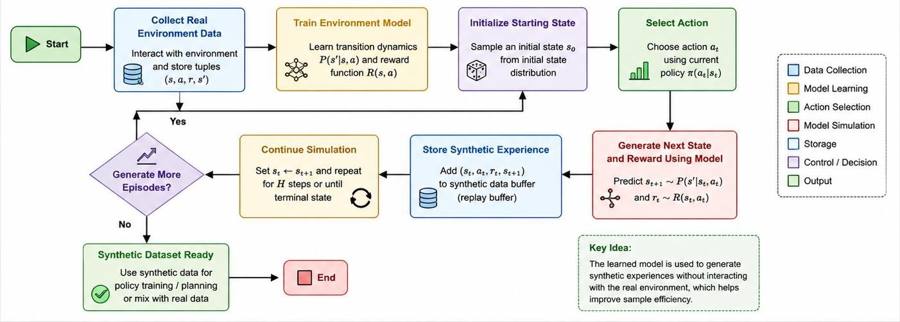

- Value-Equivalence Prediction and Policy Optimization-
Draw a block diagram illustrating the complete Model-Based Policy Optimization (MBPO) framework.
ANS: MBPO is a model-based reinforcement learning approach that combines real environment experience with short synthetic rollouts generated by a learned environment model. Real data is used to learn the model, while the model generates additional simulated experiences. Real and synthetic data are then used to optimize the policy and value functions.
Main Components
  - Real Environment Interaction – Collect real experience.
  - Real Experience Dataset – Store observed transitions.
  - Environment Model Learning – Learn state-transition and reward dynamics.
  - Synthetic Data Generation – Generate short model-based rollouts.
  - Combined Replay Buffer – Store real and synthetic experiences.
  - Policy/Value Learning – Optimize the policy using the combined data.
  - Periodic Model Update – Improve the model using new real-world data.

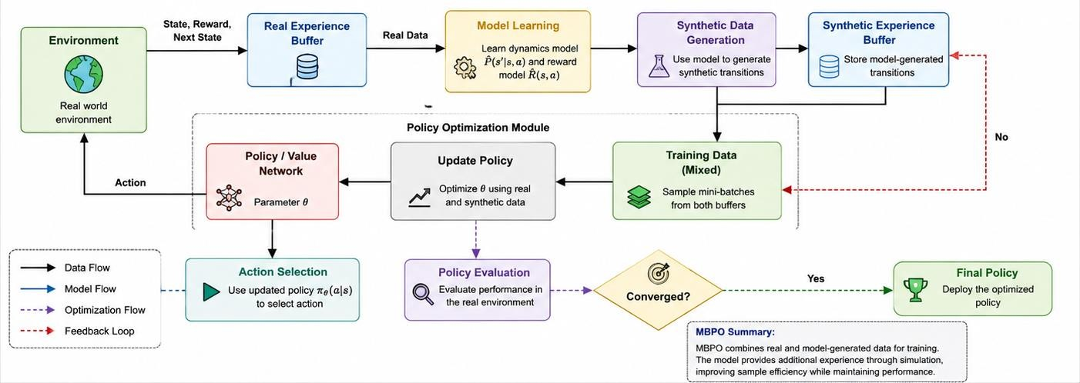
Key Benefits
      - Higher sample efficiency
      - Less real-world interaction
      - Faster policy learning
      - Combines real and simulated experience
      - Useful for complex and expensive environments

Code of Conduct:

I G. Rohit Venkat (192472107) (Name / Reg No) certify that this submission is my original work and that I have adhered to the guidelines specified for this assessment.
I understand that any violation of academic integrity rules will result in disciplinary action.

Signature of the student:
G. Rohit Venkat

RUBRICS FOR CALCULATION

Criteria | Weightage | Level 4 –  Exemplary | Level 3 –  Proficient | Level 2 –  Developing | Level 1 –  Beginning
Technical Content  Accuracy | 30 | Highly accurate, indepth, and  insightful technical explanation | Technically correct content  with adequate depth and clarity | Basic concepts presented with  limited accuracy and depth | Content contains major technical  errors; concepts poorly understood
Problem  Identification | 25 | Problem rigorously analyzed using  appropriate and advanced methods | Problem clearly defined with a logical  engineering approach | Problem  identified but analysis or  methodology is weak | Problem statement unclear or incorrect; no logical approach
Use of Tools | 20 | Advanced tools, well-analyzed data,  and highly effective  visuals | Appropriate tools and data  used effectively with clear visuals | Limited use of tools and basic data  interpretation | Minimal or incorrect use of  tools and data; poor visuals
Communication | 15 | Highly engaging, confident, and  audience-focused delivery | Clear, organized, and professional communication | Understandable but lacks clarity, structure, or confidence | Poor organization,  unclear speech, ineffective slides
Professionalism | 10 | Exemplary professionalism, leadership, and ethical awareness | Professional conduct with  effective team collaboration | Basic professionalism;  uneven team participation | Lacks professionalism; minimal  contribution or ethical awareness

